Muhammad Izham Bin Norhamadi  
B032020039

# BITS 3523

# Lab 2 Exercise

**Question 1**

Explore one of the software listed in below URL:

<https://windowsreport.com/pc-audit-software/>

Produce complete manuals that can be used for installation, how to use and others related or necessary steps.

The software chosen is **Aida64**

1. Find the download page of Aida64 at aida64.com/downloads and choose to download the exe package for Extreme edition

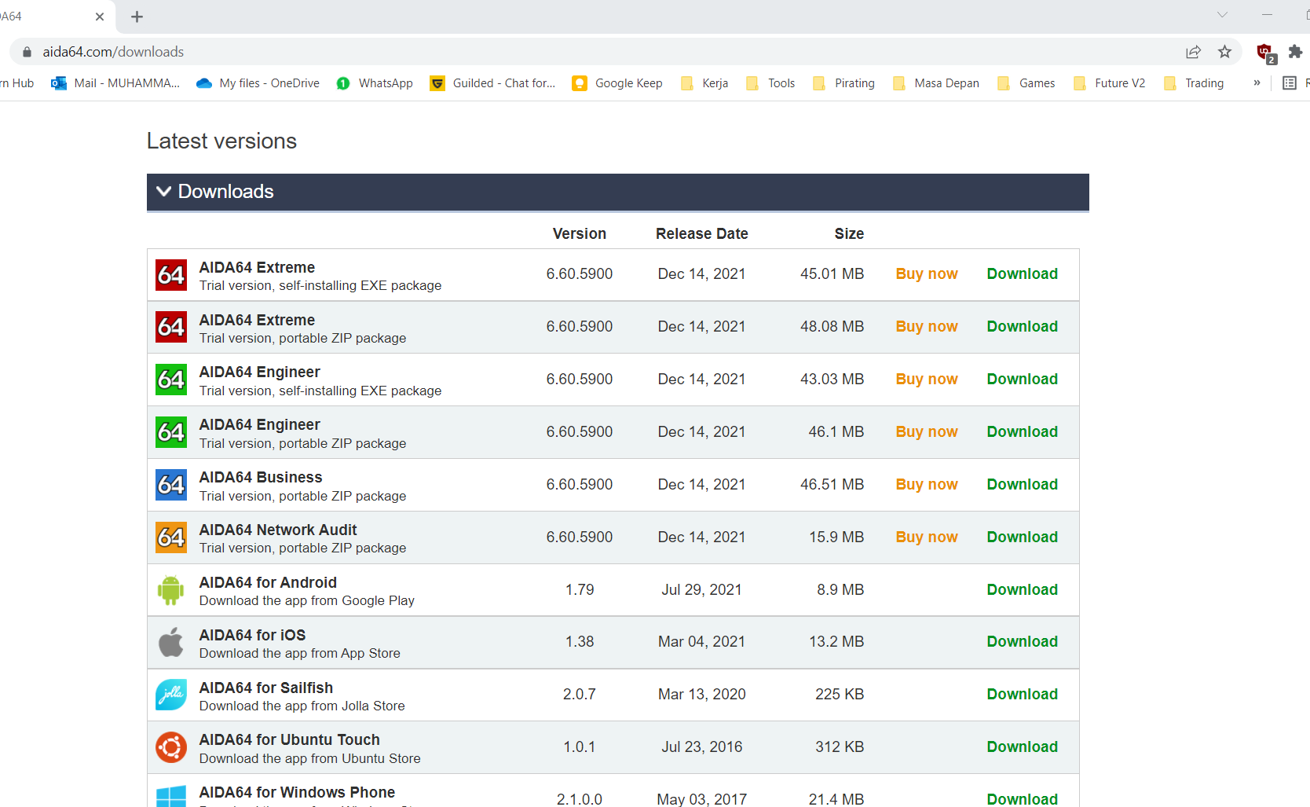

2. Follow the installation procedures

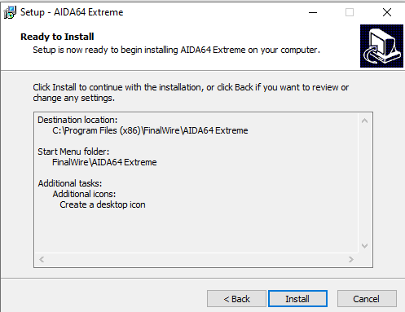

3. When the installation finished, launch Aida64 and the documentation if needed

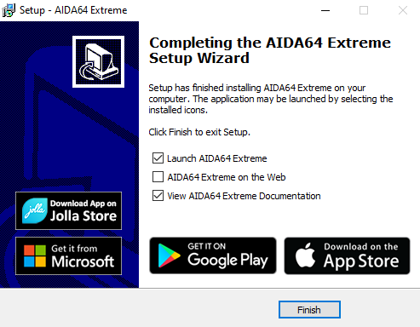

4. This is the main menu of Aida64, from here we can navigate to various menu to provide detailed information of the system.

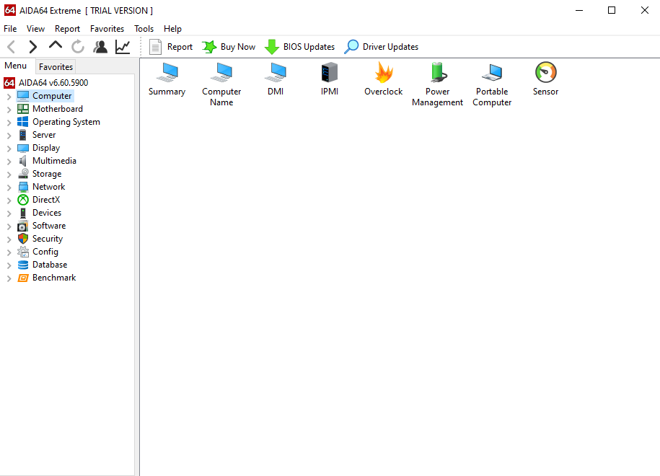

5. Click the Summary section under Computer to view the summary of the system

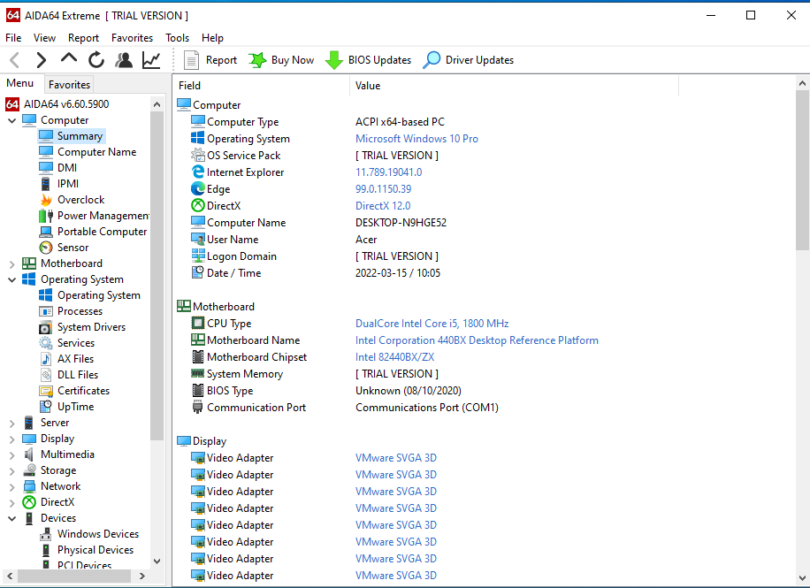

6. You can even generate a report of the system, simply click the report button and choose the desired report content.

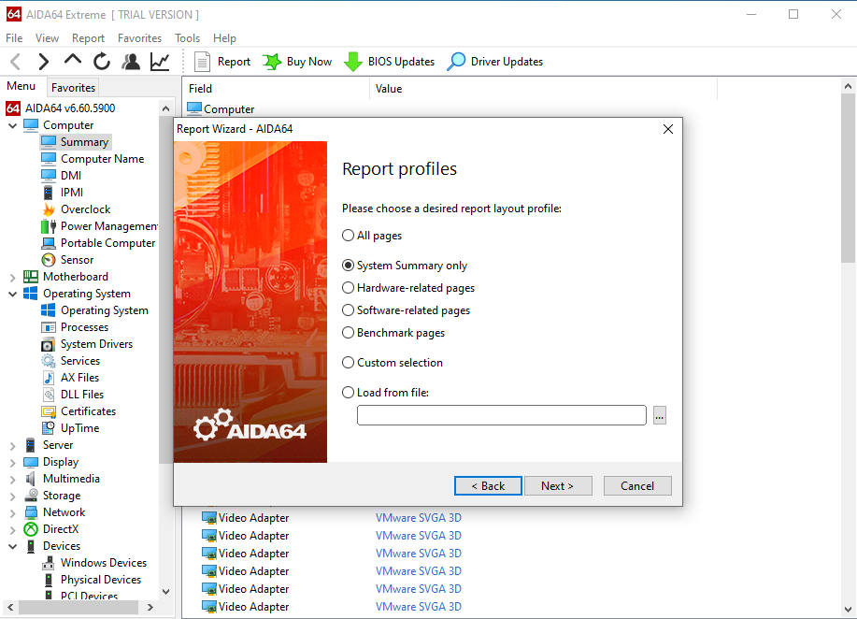

7. The report will be displayed in HTML form, and can be saved or printed.

